UNVEILING MARKETING INSIGHTS

1 INTRODUCTION

1.1 OVERVIEW

The goal to learn about and analyze the market. Data on the market, consumers and competitors must be gathered analyzed and interpreted by individuals in this role.

Marketing refers to activities a company undertakes to promote the buying or selling of a product of service.

1.2 PURPOSES

* Provides a solid foundation for strategic decision making, minimizing risks associated with uncertainty
* Meeting your target audience’s needs and wants while also profiting
* Creating brand awareness
* Retaining existing customers
* Developing new customers
* Strengthening brand association and recall

USES

Marketing insights benefit both parties and the best market insights help those selling the invention and the companies needing it.

2 PROBLEM DEFINITION AND DESIGN THINKING 2.1 EMPATHYMAP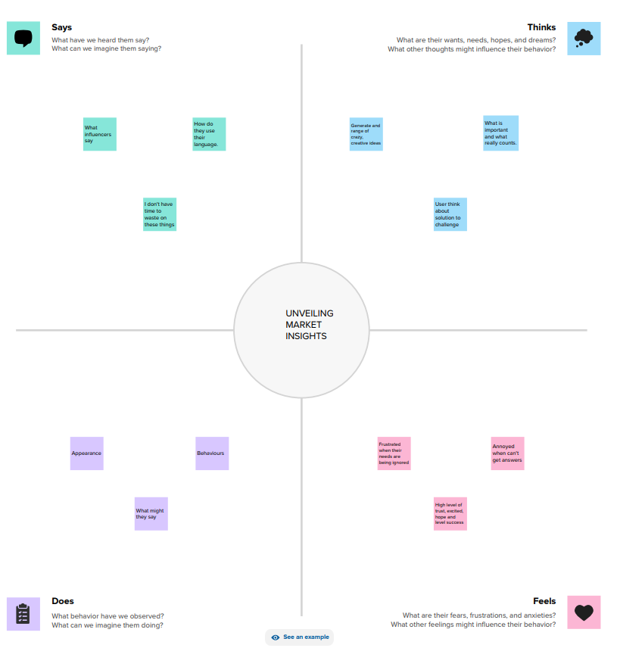

2.2 IDEASATION AND BRAINSTORMING MAP

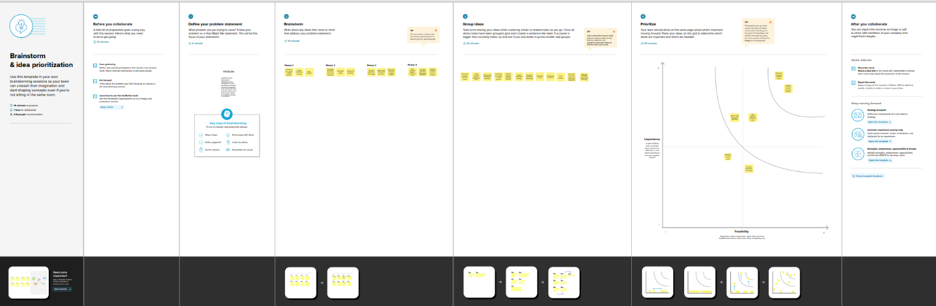

3 RESULTS

Dashboard

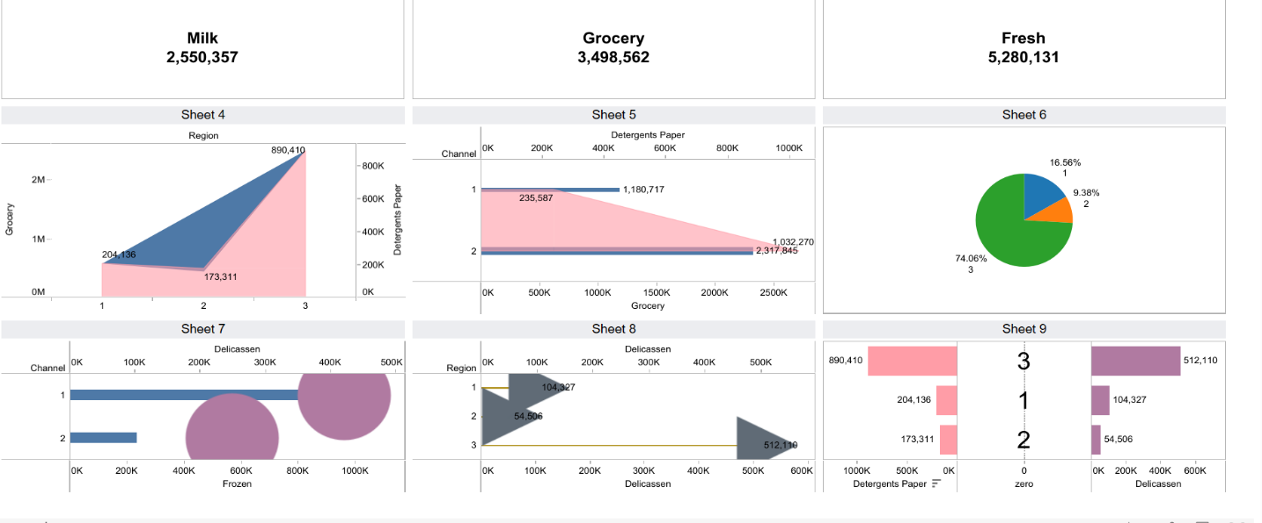

STORY

Sheet 1 - Milk

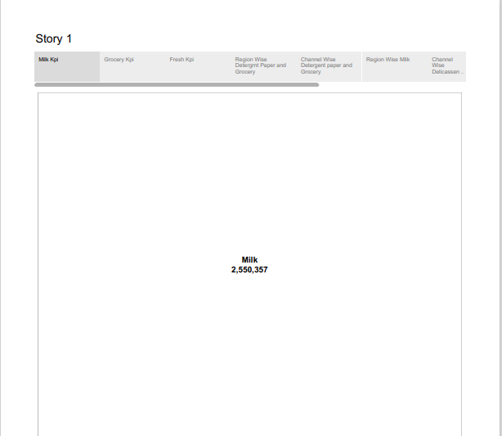

Sheet 2 – Grocery

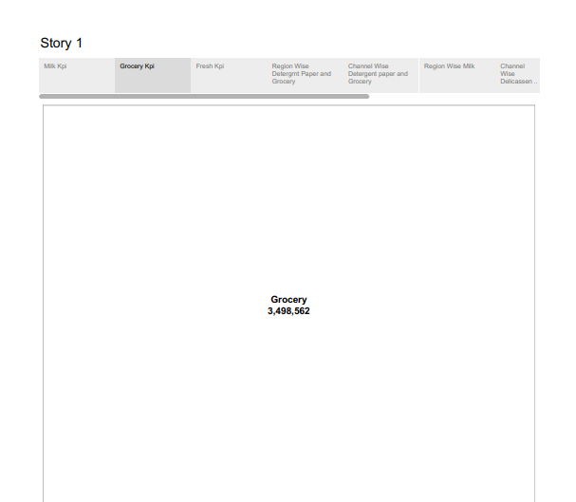

Sheet 3 - Fresh



Sheet 4 – Region wise detergent paper and grocery

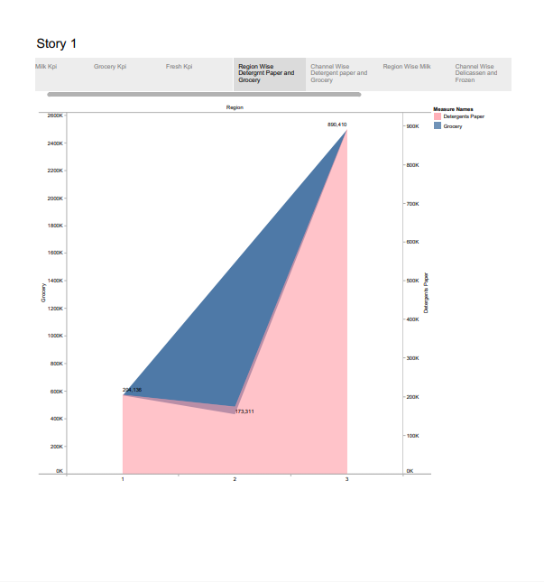

Sheet 5 – Channel wise detergent paper and grocery

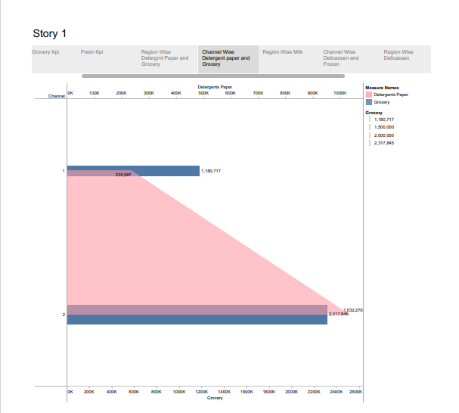

Sheet 6 – Region wise milk

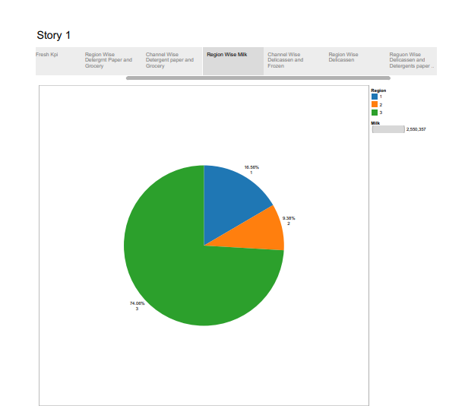

Sheet 7 – Delicassen and frozen

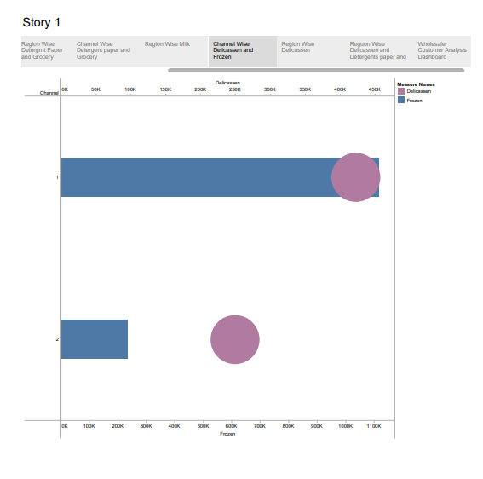

Sheet 8 – Region wise delicassen

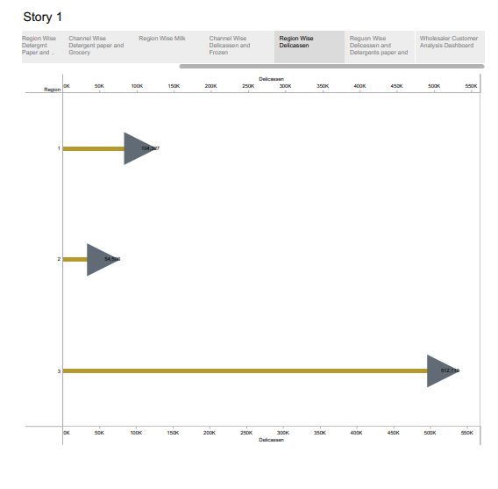

Sheet 9 – Delicassen and detergents paper

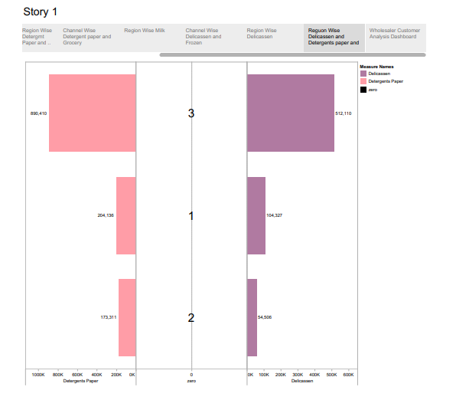

4 ADVANTAGES AND DISADVANTAGSES

ADVANTAGES:

* Better qualified leads
* Accurate buyer persons
* Increased revenue
* Better marketing materials
* Growing your sales

DISADVANTAGES:

* Can be expensive
* Requires significant time investment
* Surplus of incoming data
* Not easy to measure the return investment
* Outdated information

5 APPLICATIONS

Companies can directly interact with their customers and find out what content, goods, or services they want.

Understanding the needs and wants of the target audience helps companies better understand their customer preferences. Professional who works in a corporation’s marketing and departments seek to get the attention of key potential audiences through advertising.

Help companies develop strategies quicker and more effectively, identify new opportunities, monitor performance and forecast future demands or supply.

6 CONCLUSIONS

A business organization’s marketing objectives should be consistent and specify the primary concern of the organization. This involves your goals flowing from your organization’s mission statement to the financial goals and finally to the rest of the marketing strategy.

The marketing concept is the philosophy where each and every firm should analyze the needs of their customers and makes good decisions in order to satisfy their needs. This also enhance a good relationship between the customers.

Today marketing is not simply confined to promoting and selling goods and services. It encompasses so much more, both in terms of operations and the subject of marketing.

7 FUTURESCOPE

The future scope of marketing is increasing exponentially. It involves researching, planning and coordinating. The growth of digital technologies and the internet have positively impacted marketing scope.

Moreover, marketing is not limited to just goods or services anymore. Today, marketing also includes marketing events, persons, experiences, properties, places, organizations, information and ideas.